
CAPISTRANO VALLEY HIGH SCHOOL
http://cvhs.schoolloop.com/26301 Via Escolar, Mission Viejo, CA 92692
GIRLS LACROSSE Head Coach: Ryan Gustafson rrgustafson@capousd.org
Assistant Coach: Danielle Zahn

2017 Fund Raising Packet

Welcome to the 2017 Girls Lacrosse season. The primary source of the team’s financial support is through voluntary player donations. This packet includes information on all of the tools that you can use to fund raising to earn all or part of your voluntary donation of $450. The Girl’s Lacrosse Boosters will track all fund raising activities in order to keep you informed of your donations.

This packet includes information for:
• Scrip gift cards through www.shopwithscrip.com -­‐ earn various percentages by purchasing
gift cards for items that you already buy – You start earning with your first purchase
o What it is
o Getting started
o How to sign up for ScripNow, Reload and PrestoPay
o Capo Girls Lacrosse Code: 9E1B144727717
• Stadium banner order form – earn up to $400 per banner sold – Due ASAP
• Yankee Candles – easy on-­‐line ordering for candles that earn up to 40% -­‐ You earn with
every purchase throughout the year
• Company donation form – earn 100% of all company donations – Due: ASAP
• Ralph’s and Von’s – earn when you shop for groceries – You start earning as soon as you
sign up.
o Ralphs –
      - Sign up on-­‐line at http://www.ralphs.com using our group number 93331
OR
      - Sign up in store by scanning the enclosed form at check out
o Vons/Pavillions
      - Turn in the enclosed forms
OR
      - Sign up on-­‐line at
http://www.screencast.com/t/SSvBcSlr2F#sthash.5yTSedzK

Thank you,

CVHS Girls Lacrosse Booster Club
capoglax@gmail.com



Fundraising

WHILE YOU

Stop selling and start earning! Scrip fundrais1ng is a no-selling program that allows families to raise money for their non-profit organizanon (NPO). Scrip is just another way to pay for everyday purchases using g1ft ca rds in place of cash, checks, and credit cards.

You purchase gift cards from your organization at face value,and your coordinator orders those cards from Great lakes Scrip Center at a red uced price. The difference is an instant rebate for your organizanon.It's really that simple!

When you use scrip gift cards at your favorite retailers,your' e fundraising while you shop. Great akes Scrip Center offers over 300 of the count,.Ys biggest brands,including grocery,department stores,gas stations,restaurants,hotels,home improvement,and more. Just by using scrip to pay for your normal weekly purchases,you can easily raise $500 or more per year. It's. nme to put your shopping dollars to

work!


1,/1/(( ., I \rilr/1•
(rr( I (t l.l

*

n.c...c•ll>lflh,.•cto"'N.,t"'>I S--'••r'"'J' "''')OoOI•oe<•..ell'l"l.., M#!GocOil OdS<•., ••• l> le<t>t...,(llfoc••Jto'l.il)o'lt
...S .WI :Ic'"O"' (II...-.NI.>y ll- (t!ff*"I•''-''Oo<!IOIUJ fl P - ««f*'Of'l-ciWI<IO'ooHI.i le•.,l ((lt>jl)
shopwrthscrip com


Getting Started at

ShopWithScrip.com is the online ordering system that our organization will use to gather family scrip orders. Using your free ShopWithScrip account, you will be able to order scrip anytime you’re connected to the internet.
It’s so convenient!

How to Register
Code for Capo Girls Lacrosse: 9E1B144727717

To place your script orders, you need to first create a ShopWithScript account. Go to www.shopwithscrip.com and click on the ‘Register’ button at the top of the page. Next, click “Join a Scrip Program’. You will then need to enter our organization’s unique enrollment code. This code allows the ShopWithScript system to link your account activity with our organization.

Next, fill in all the required information and click ‘Register’. You will be asked to select two challenge questions and provide answers, which will be required if you forget your password. Keep in mind that your answers are case-sensitive.

Using ShopWithScrip.com

You can manage your account through your Dashboard, which you can access by clicking the ‘Dashboard’ link at the top of any page. From here, you can check your account activity, change your profile and password, add, remove, and modify organizations you belong to, and read coordinator announcements. You can also run your own order and rebate history reports and view or print and ScripNow eCards tht you’ve previously ordered.

It’s Easy to Order

You can login and place orders a few different ways:
Shop Tab: Looking for a gift ? Not sure what’s available? Click ‘Shop’ at the top of the page and use this feature to sort products and browse by category, card type, or rebate percentage.
Express Order: Know exactly what you want ? Quickly add the items to your cart using this feature.

Shopping Lists: Order the same products each week ? Add these items to a shopping list for easy ordering, then set reminders so you get an email when it’s time to place another order.

© 2014 Great Lakes Scrip Center LLC




COUGAR STADIUM BANNER ORDER FORM

Banner Lay-­‐out will meet the following guidelines:
      - Banner cost: $525* (Payable to CVHS Girls Lacrosse Boosters)
      - 8’ x 3’ size
      - Full color banner – Sponsor provided logo/artwork
      - Banners will be placed along interior stadium fence (visible to both stands)
      - All banner production by Signs Plus

2016-2017 One-­‐year contract agreement

Business/Company:________________________________________________________________________ Business Address: _________________________________________________________________________

________________________________________________________________________________________________

Business Contact Person: (regarding layout design, font, banner specifics, etc):

________________________________________________________________________________________________ Contact Phone #:___________________________________________________________________________ Contact Email:______________________________________________________________________________ CVHS Athletic Team Sponsoring:_________________________________________________________
Thank you for supporting Capistrano Valley High School Cougar Athletics!
Signs Plus designer, Fran Ratcliffe (email: signsoc@aol.com , Office: 949-­‐489-­‐
0352/Fax: 949-­‐612-­‐0020) will contact with you regarding specific banner
information and logo (*additional $75 charge for elaborate detail and artwork may apply)
Check #
Date




EARN 40 PERCENT PROFIT

CAPO VALLEY GIRLS LACROSSE
Group Number: 990046777

Dear Supporters of CAPO VALLEY GIRLS LACROSSE;

The online fundraising program with Yankee Candle is awesome! 40% of the price you pay for your favorite Yankee Candle products will go directly to CAPO VALLEY GIRLS LACROSSE! No collection of monies, no distribution of products and no missing and/or damaged issues.

Here how it works:
You can order Yankee Candle products on-­‐line-­‐-­‐delivered directly to your home or sent as a gift to your friends
and family. You can also invite friends and family to shop for their own items and earn for the team.
Orders over $100 have free shipping!

CAPO VALLEY GIRLS LACROSSE will get a 40 % rebate on all products purchased. As long as you set up a
“seller ID” as discussed below and have all your orders and your customer orders identified, the boosters will
be able to track the sales for fundraising credit toward your player donation!! / It’s that simple.

Our fundraising program runs from today through until the end of June 2016. So make use of every
Gift Giving opportunity to reach out to your friends and family and remind them how they can help!!
Don’t wait, seasonal items are now available! Think about all the wonderful holidays coming
up as well as any other gift giving opportunities you might have!

To get started, simply go to www.yankeecandlefundraising.com, In the Start Shopping Box, click Create Seller Login. Insert our special group code 990046777 and birthday under Sign Up to Be A Seller. Follow steps 1-­‐3 to confirm your e-­‐mail address. Even if you sold in our Spring 2014 fundraiser you need to set up a new seller account. You will be on your way to supporting CAPO VALLEY GIRLS LACROSSE. Start shopping and share this number with friends and family.

Once you have registered with Yankee Candle, you have the opportunity to send out emails to “Friends and Family” for their support. Simply enter their name and e-­‐mail on the Seller Dashboard and Yankee Candle will send out an e-­‐mail on behalf of you and CAPO VALLEY GIRLS LACROSSE. You may preview the e-­‐mail before sending. Share this great offer with your out of town “Friend and Family” 40% of their purchases will also go to CAPO VALLEY GIRLS LACROSSE. Remember, don’t forget your co-workers.

We will keep you updated on our results. Thank you for your continued support.

Sharon Scoles
CVHS Girls Lacrosse Yankee Candle Coordinator

Support the 2017 Capistrano Valley High School

Girls Lacrosse Program

Donate $200 or more and your company logo will be displayed on www.cvhs.com/girlslacrosse

Proceeds directly support the CVHS Girls Lacrosse program, a not for profit organization.
All donations are tax deductible

*************************************************************************************************************** Sponsor Information

Business Name:

Business Address:

Contact Person:

Phone #: Email:

CVHS Contact Person:

Phone #: Email:

Thank you for supporting Capistrano Valley High School Girls Lacrosse!

Check # Date

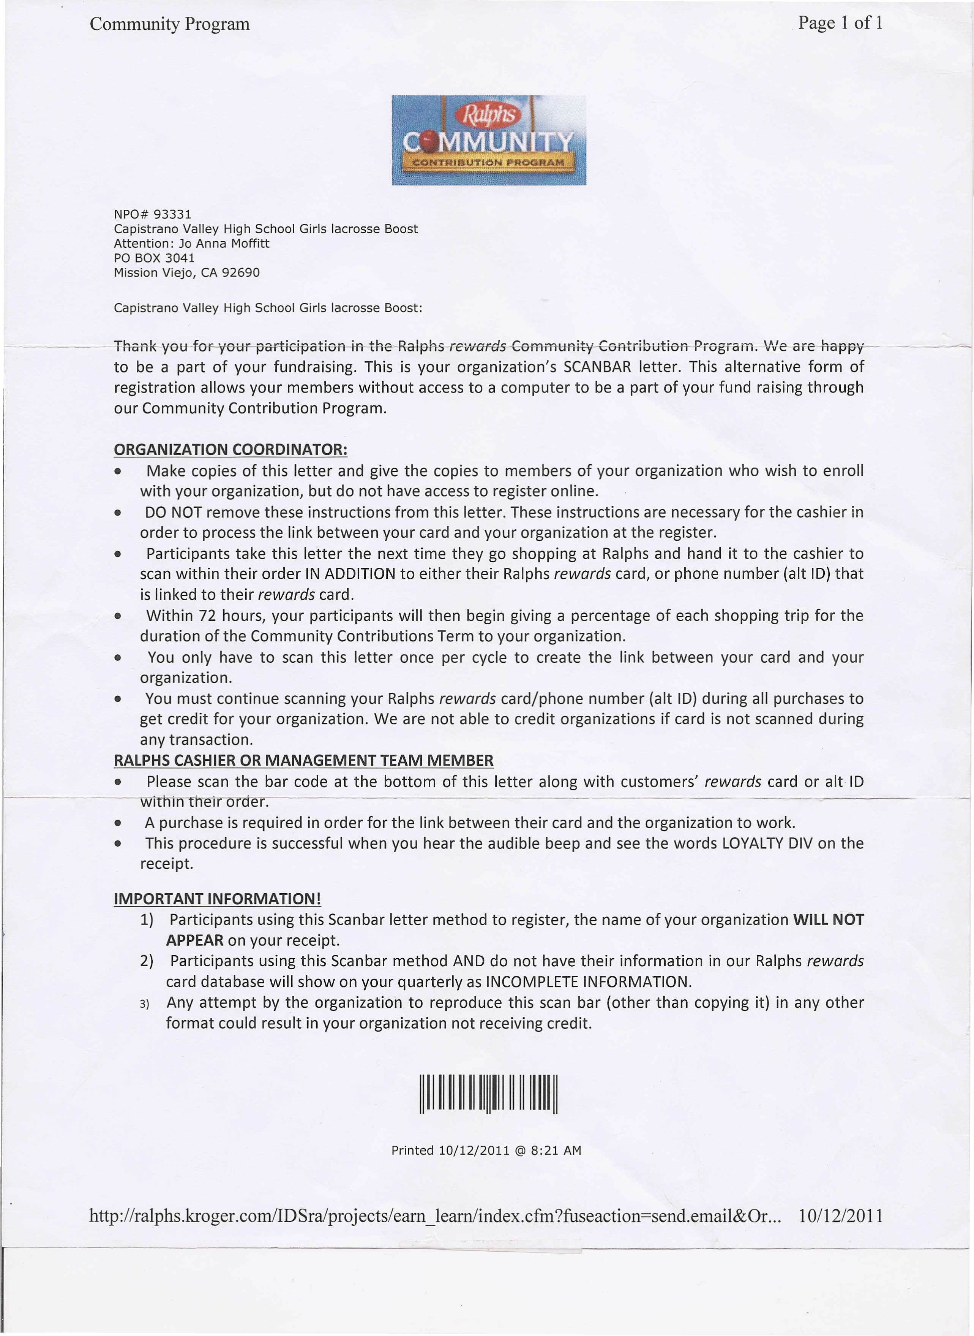

put education on your shopping list


It’ s Free It’ s Easy It’ s Powerful

Register Your VONS Club Card Today and Earn Money for Your School

555 5555 5555

VONS Club Card Number

Group Name Group ID # (if unknown, leave blank) Last Name First Name
Address

City State Zip

Email Address Phone Number

Note: All lines required. Confirmation email will be sent to email listed above.

Return form to:

put education on your shopping list

It’ s Free It’ s Easy It’ s Powerful

Register Your VONS Club Card Today and Earn Money for Your School

555 5555 5555

VONS Club Card Number

Group Name Group ID # (if unknown, leave blank) Last Name First Name
Address

City State Zip

Email Address Phone Number

Note: All lines required. Confirmation email will be sent to email listed above.

Return form to:

